|  |  |  |
| --- | --- | --- |
| **Project Design Document** | |  | | --- | | *02/05/2022*  The Christmas Factory | |

|  |  |  |  |
| --- | --- | --- | --- |
| **Project Concept** | | | |
| **1** **Player Control** |  | You control a   |  | | --- | | *Elf* | | in this   |  |  | | --- | --- | | *Side view* | game | |
|  | where   |  | | --- | | *W,A,S,D* | | makes the player   |  | | --- | | *Move vertically and horizontally.* | |

|  |  |  |  |  |  |  |
| --- | --- | --- | --- | --- | --- | --- |
| **2** **Basic**  **Gameplay** |  | During the game,   |  |  | | --- | --- | | *Toys*  *Supervisor* | appear | | from   |  | | --- | | *conveyor belt*  *door* | |
|  | and the goal of the game is to   |  | | --- | | *gift-wrapping them* | | |

|  |  |  |  |  |  |
| --- | --- | --- | --- | --- | --- |
| **3** **Sound**  **& Effects** |  | There will be sound effects   |  | | --- | | *wrapping the toy*  *broken belt conveyor*  *elf talking*  *supervisor talking*  *elf having coffee* | | and particle effects   |  | | --- | | *wrapping the toy*  *broken belt conveyor* | |
|  | [*optional*] There will also be   |  | | --- | | *christmas music affected by player stress measurement* | | |

|  |  |  |  |  |  |
| --- | --- | --- | --- | --- | --- |
| **4** **Gameplay**  **Mechanics** |  | As the game progresses,   |  | | --- | | *toys appear faster*  *supervisors come to yell at you*  *supervisors come to cheer you up*  *the toys stop appearingla*  *conveyor machine breaks down*  *stress bar increases* | | making it   |  | | --- | | *increase stress when wrapping*  *increase stress immediately*  *decrease stress immediately*  *gives the elf time to talk or have coffee*  *gives the elf time to talk or have coffee*  *giving the elf the ability to sustain longer* | |
|  | [*optional*] There will also be   |  | | --- | | *Need other elves on the map to talk (players or npc)* | | |

|  |  |  |  |  |  |  |  |
| --- | --- | --- | --- | --- | --- | --- | --- |
| **5** **User**  **Interface** |  | The   |  | | --- | | *wrapped gifts* | | will   |  | | --- | | *increase* | | whenever   |  | | --- | | *the elf wraps a gift* | |
|  |  | |  |
|  |  | The   |  | | --- | | *stress bar* | | will   |  | | --- | | *Increase*  *decrease* | | whenever   |  | | --- | | *the elf wraps a gift*  *the elf talks or has a coffee* | |
|  | At the start of the game, the title   |  |  | | --- | --- | | *The Christmas Factory* | will appear | | | and the game will end when   |  | | --- | | *stress bar reaches limit* | |

|  |  |  |  |
| --- | --- | --- | --- |
| **6** **Other Features** |  | |  | | --- | | *There is a gift counter for each elf.*  *There is a global gift counter for the factory.*  *Single player or cooperative game mode.*  *In the single player game mode the other elves have AI.* | |

# **Project Timeline**

|  |  |  |
| --- | --- | --- |
| **Milestone** | **Description** | **Due** |
| **#1** | |  | | --- | | * *Write the foundation of the project design document.* | | |  | | --- | | *02/05* | |
| **#2** | |  | | --- | | * *Create the base unity project* | | |  | | --- | | *02/05* | |
| **#3** | |  | | --- | | * *Code Player Elf Movement* | | |  | | --- | | *02/05* | |
| **#4** | |  | | --- | | * *Code Toy Elf Movement* | | |  | | --- | | *02/05* | |
| **#5** | |  | | --- | | * *Code Toy Spawner* | | |  | | --- | | *02/05* | |
| **#6** | |  | | --- | | * *Code Endpoint, Toys and Player Collisions* | | |  | | --- | | *02/05* | |
| **#7** | |  | | --- | | *Code Conveyor Manager and Polling Base* | | |  | | --- | | *03/05* | |
| **#8** | |  | | --- | | *Create Endpoint cursor* | | |  | | --- | | *03/05* | |
| **#9** | |  | | --- | | * *Core Mechanic: Gift-wrapping* | | |  | | --- | | *04/05* | |
| **#10** | |  | | --- | | * *Stress system* | | |  | | --- | | *05/05* | |

|  |  |  |  |  |
| --- | --- | --- | --- | --- |
| **#11** | |  | | --- | | * *Code Talk to another elf* | | |  | | --- | | *06/05* | |
| **#12** | |  | | --- | | * *Supervisors come to yell/cheer at you* | | |  | | --- | | *06/05* | |
| **#13** | |  | | --- | | * *Code Talk to another elf* | | |  | | --- | | *06/05* | |
| **#14** | |  | | --- | | * *Code have coffee* | | |  | | --- | | *07/05* | |
| **#15** | |  | | --- | | * *Callout System* | | |  | | --- | | *08/05* | |
| **#16** | |  | | --- | | * *Pixel Perfect Camera* | | |  | | --- | | *09/05* | |
| **#17** | |  | | --- | | * *Code Audio Manager* | | |  | | --- | | *09/05* | |
| **#18** | |  | | --- | | * *Global Post Processing* | | |  | | --- | | *09/05* | |
| **#19** | |  | | --- | | * *Refactor supervisor orders* | | |  | | --- | | *10/05* | |
| **#20** | |  | | --- | | * *Stress Events* | | |  | | --- | | *10/05* | |
| **#21** | |  | | --- | | * *Elf Animation: Walk and Idle* | | |  | | --- | | *11/05* | |
| **#22** | |  | | --- | | * *Elf Animation Controller* | | |  | | --- | | *12/05* | |
| **#23** | |  | | --- | | * *Supervisor Animation Controller* | | |  | | --- | | *13/05* | |
| **#24** | |  | | --- | | * *Conveyor Animation Controller* | | |  | | --- | | *13/05* | |
| **#25** | |  | | --- | | * *Code break and work time* | | |  | | --- | | *14/05* | |
| **#26** | |  | | --- | | * *Refactor Player Input* | | |  | | --- | | *16/05* | |
| **#27** | |  | | --- | | *Other Elf IA: Wrap* | | |  | | --- | | *17/05* | |
| **#28** | |  | | --- | | *Other Elf IA: Walk* | | |  | | --- | | *18/05* | |
| **#29** | |  | | --- | | *Other Elf IA: Talk* | | |  | | --- | | *18/05* | |
| **#30** | |  | | --- | | *Other Elf IA: License* | | |  | | --- | | *19/05* | |
| **#23** | |  | | --- | | *Landing UI Placeholder* | | |  | | --- | | *19/05* | |
| **#24** | |  | | --- | | *Difficulty Manager* | | |  | | --- | | *19/05* | |
| **#25** | |  | | --- | | *Game Over UI* | | |  | | --- | | *14/05* | |
| **#26** | |  | | --- | | *Option UI* | | |  | | --- | | *16/05* | |
| **#27** | |  | | --- | |  | | |  | | --- | | *17/05* | |
| **#28** | |  | | --- | |  | | |  | | --- | | *18/05* | |
| **#29** | |  | | --- | |  | | |  | | --- | | *18/05* | |
| **#30** | |  | | --- | |  | | |  | | --- | | *18/05* | |
| **#23** | |  | | --- | |  | | |  | | --- | | *13/05* | |
| **#24** | |  | | --- | |  | | |  | | --- | | *13/05* | |
| **#25** | |  | | --- | |  | | |  | | --- | | *14/05* | |
| **#26** | |  | | --- | |  | | |  | | --- | | *16/05* | |
| **#27** | |  | | --- | |  | | |  | | --- | | *17/05* | |
| **#28** | |  | | --- | |  | | |  | | --- | | *18/05* | |
| **#29** | |  | | --- | |  | | |  | | --- | | *18/05* | |
| **#30** | |  | | --- | |  | | |  | | --- | | *18/05* | |

# **Project Sketch**

**Demo 01**

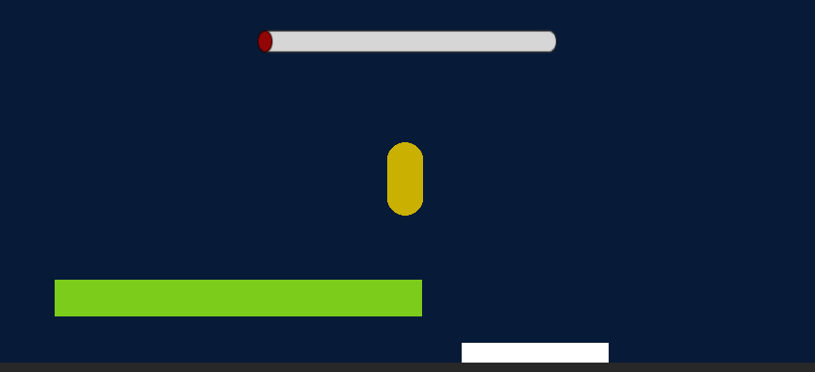

**Demo 02**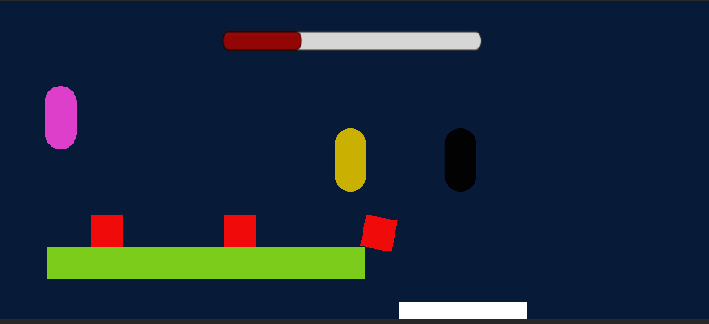

**Demo 03**

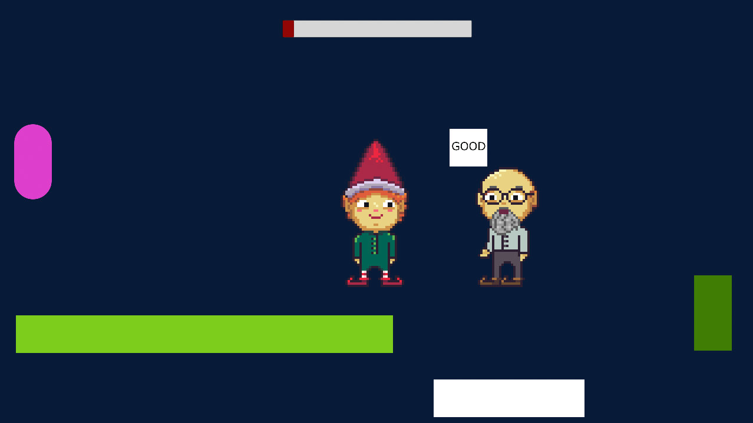

**Demo 04**

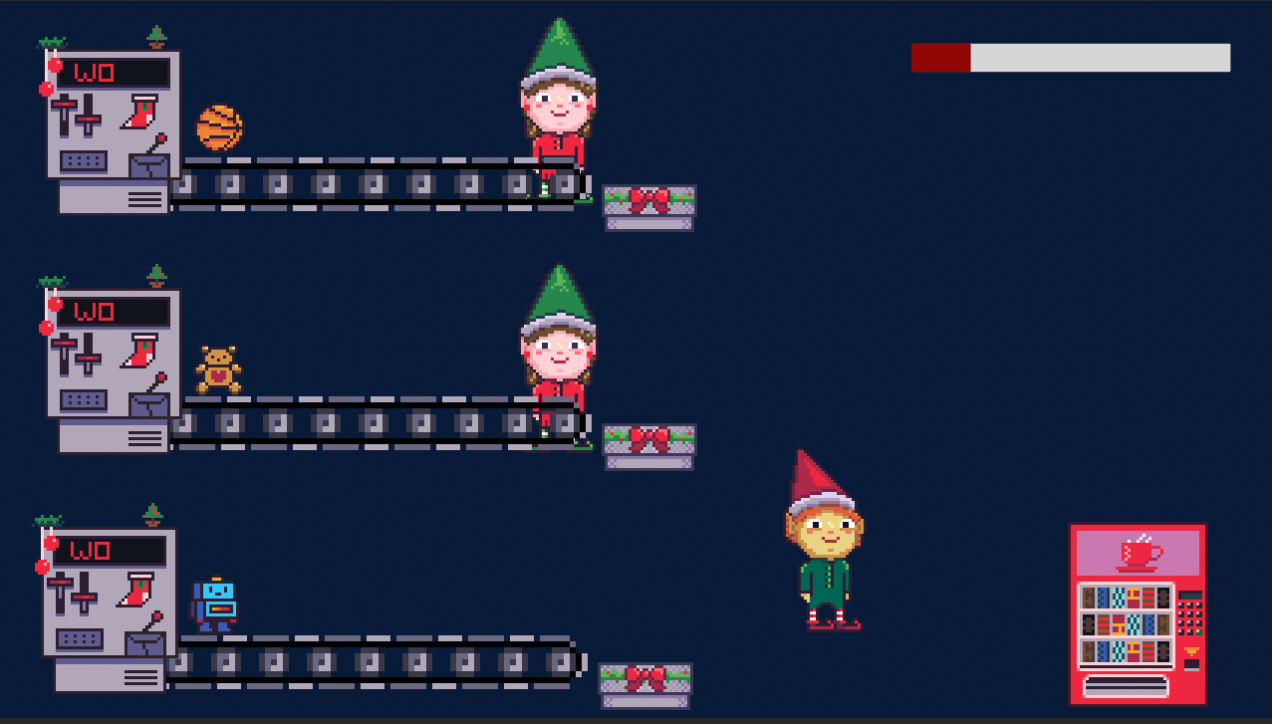

**Demo 03**

**Demo 03**

**Demo 03**

**Demo 03**